FLIP-FLOPS
R-S Flip-Flop
A flip-flop is a bistable circuit. Both of its output states are stable. The circuit remains in a particular output state indefinitely until something is done to change that output status. The R-S flip-flop is the most basic of all flip-flops. The letters ‘R’ and ‘S’ here stand for RESET and SET. When the flip-flop is SET, its Q output goes to a ‘1’ state, and when it is RESET it goes to a ‘0’ state. The Ǭ output is the complement of the Q output at all times.

R-S Flip-Flop with Active LOW Inputs
The figure below shows a NAND gate implementation of an R-S flip-flop with active LOW inputs. The two NAND gates are cross-coupled. That is, the output of NAND 1 is fed back to one of the inputs of NAND 2, and the output of NAND 2 is fed back to one of the inputs of NAND 1. The remaining inputs of NAND 1 and NAND 2 are the S and R inputs. The outputs of NAND 1 and NAND 2 are respectively Q and Ǭ outputs.
The fact that this configuration follows the function table below can be explained.
Let us take the case of R = S = 1 (the first entry in the function table). We will prove that, for R = S = 1, the Q output remains in its existing state. In the truth table, Qn represents the existing state and Qn+1 represents the state of the flip-flop after it has been triggered by an appropriate pulse at the R or S input. Let us assume that Q = 0 initially. This ‘0’ state fed back to one of the inputs of gate 2 ensures that Ǭ= 1. The ‘1’ state of Ǭ fed back to one of the inputs of gate 1 along with S = 1 ensures that Q = 0. Thus, R = S = 1 holds the existing stage. Now, if Q was initially in the ‘1’ state and not the ‘0’ state, this ‘1’ fed back to one of the inputs of gate 2 along with R = 1 forces Ǭ to be in the ‘0’ state. The ‘0’ state, when fed back to one of the inputs of gate 1, ensures that Q remains in its existing state of logic 1’. Thus, whatever the state of Q, R = S = 1 holds the existing state.
Let us now look at the second entry of the function table where S = 0 and R = 1. We can see that such an input combination forces the Q output to the ‘1’ state. On similar lines, the input combination S = 1 and R = 0 (third entry of the truth table) forces the Q output to the ‘0’ state. It would be interesting to analyse what happens when S = R = 0. This implies that both Q and Ǭ outputs should go to the ‘1’ state, as one of the inputs of a NAND gate being a logic ‘0’ should force its output to the logic ‘1’ state irrespective of the status of the other input. This is an undesired state as Q and Ǭ outputs are to be the complement of each other. The input condition (i.e. R=S =0) that causes such a situation
is therefore considered to be an invalid condition and is forbidden. The R and S inputs in the symbol have been shown as active LOW inputs, which is obvious as SET (that is, Q=1) is when S =0 and RESET (that is, Q=0) is when R = 0. Thus, R and S are active when LOW. The term CLEAR input is also used sometimes in place of RESET. The operation of the R-S flip-flop can be summarized as follows:
1. SET=RESET= 1 is the normal resting condition of the flip-flop. It has no effect on the output state of the flip-flop. Both Q and Ǭ outputs remain in the logic state they were in prior to this input condition.
2. SET = 0 and RESET = 1 sets the flip-flop. Q and Ǭ respectively go to the ‘1’ and ‘0’ state.
3. SET =1 and RESET =0 resets or clears the flip-flop. Q and Ǭ respectively go to the ‘0’ and ‘1’ state.
4. SET = RESET = 0 is forbidden as such a condition tries to set (that is, Q = 1 ) and reset (that is, Ǭ= 1) the flip-flop at the same time. To be more precise, SET and RESET inputs in the R-S flip-flop cannot be active at the same time.
The R-S flip-flop below is also referred to as an R-S latch. This is because any combination at the inputs immediately manifests itself at the output as per the truth table.
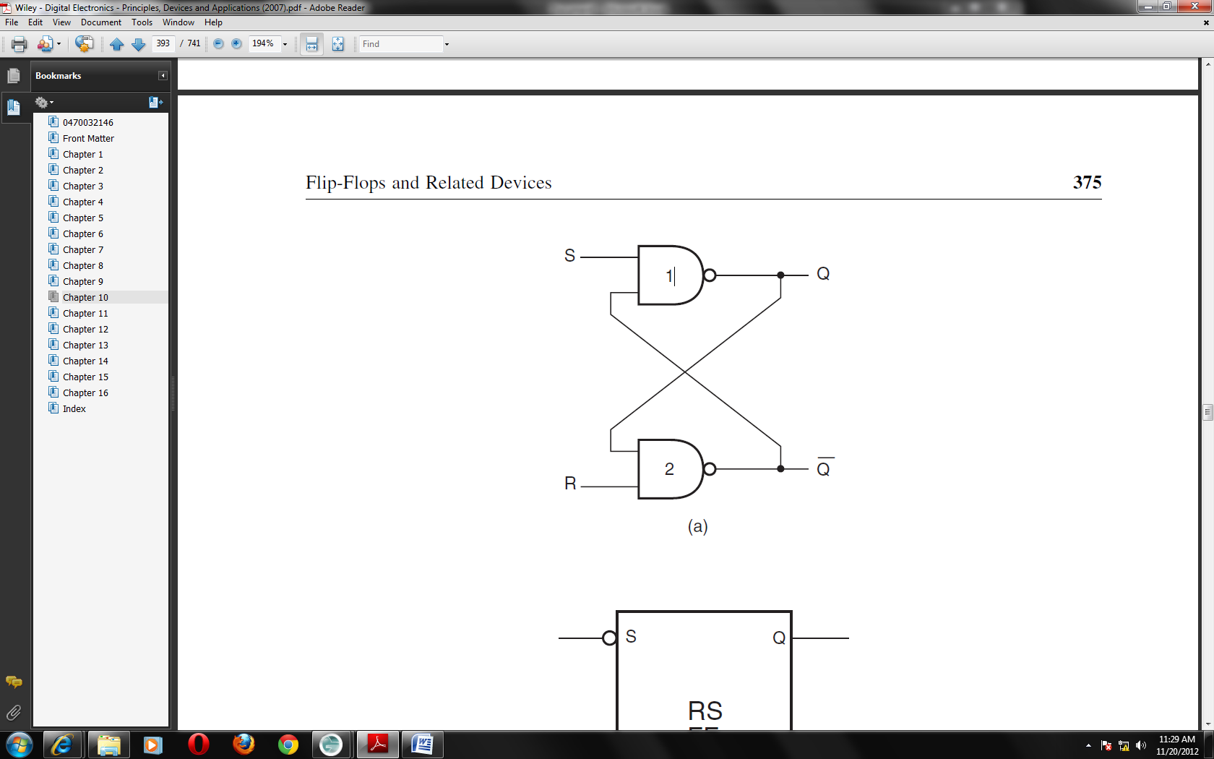
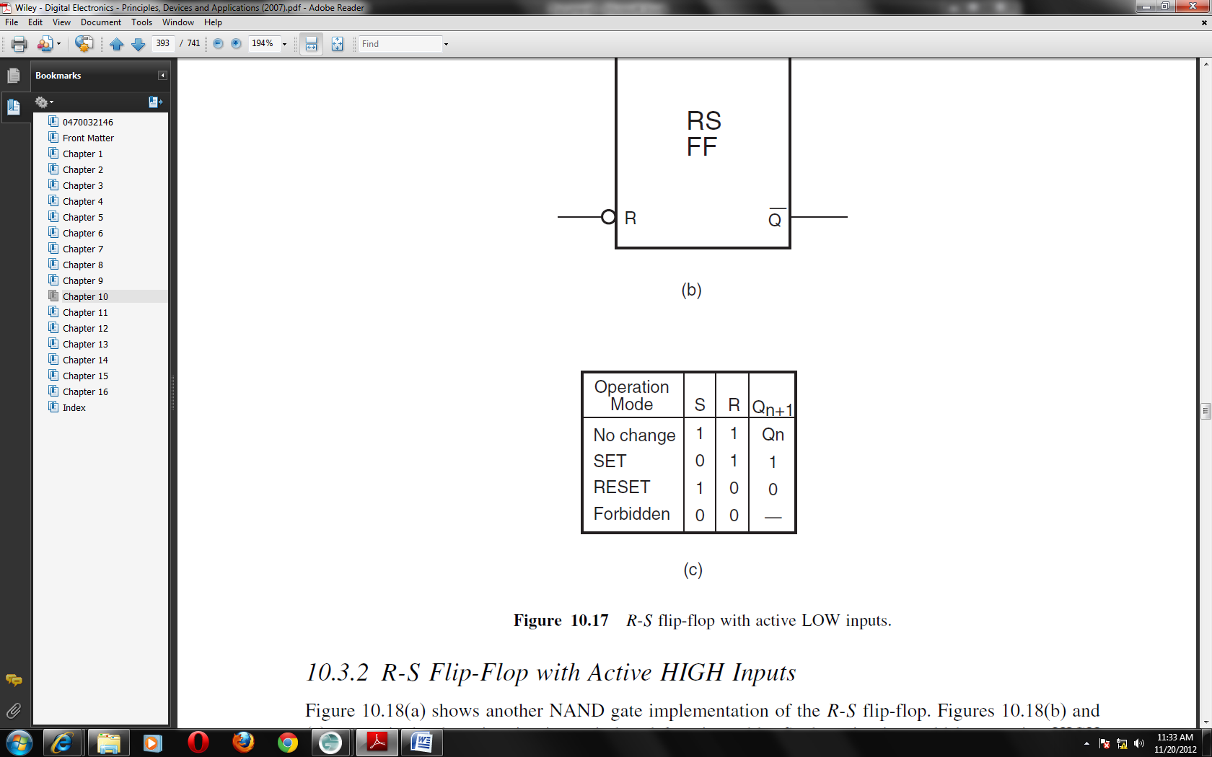
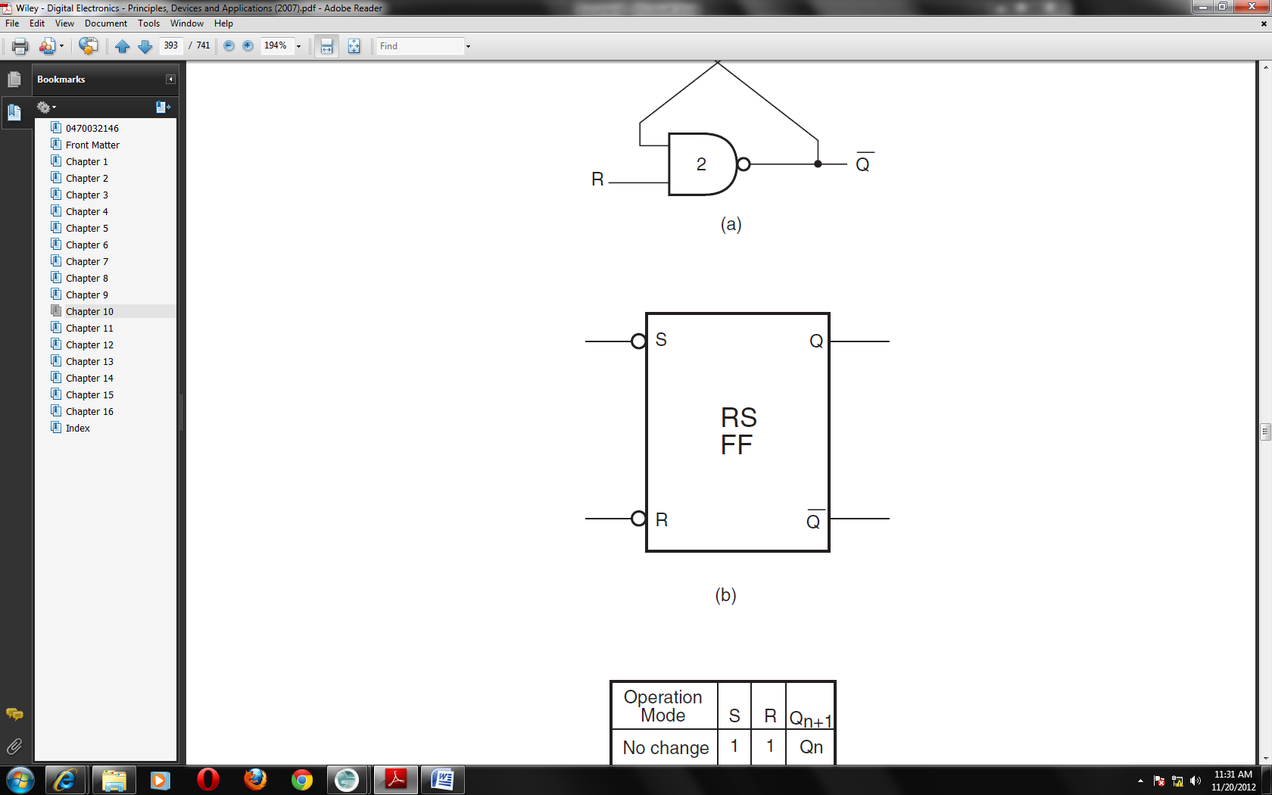

R-S Flip-Flop with Active HIGH Inputs
The figure below shows another NAND gate implementation of the R-S flip-flop together with its circuit symbol and function table. Such a circuit would have active HIGH inputs. The input combination R = S = 1 would be forbidden as SET and RESET inputs in an R-Sflip-flop cannot be active at the same time.
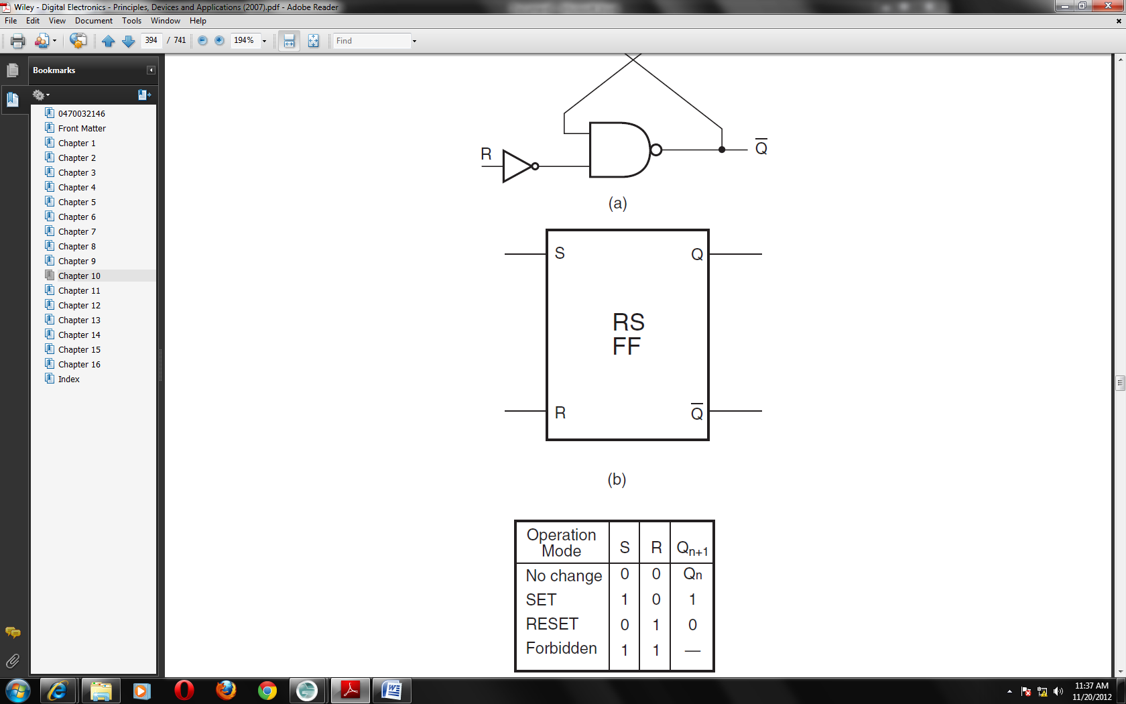
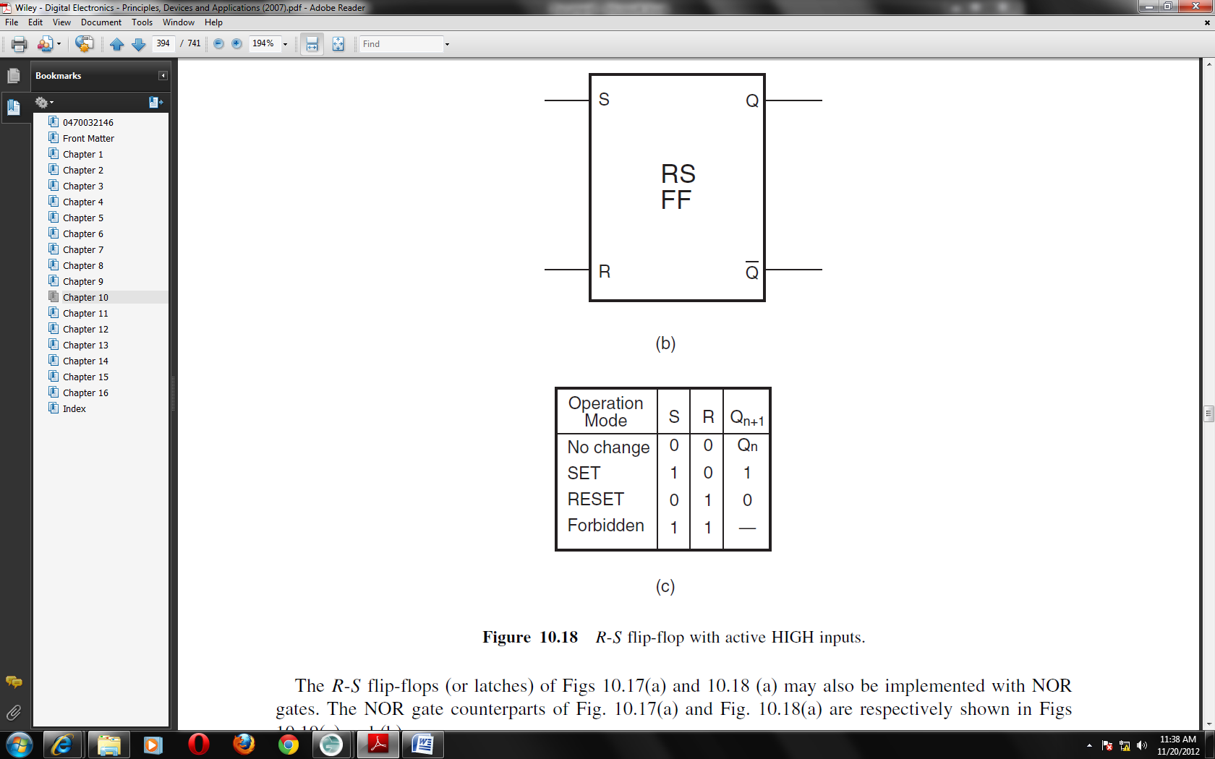
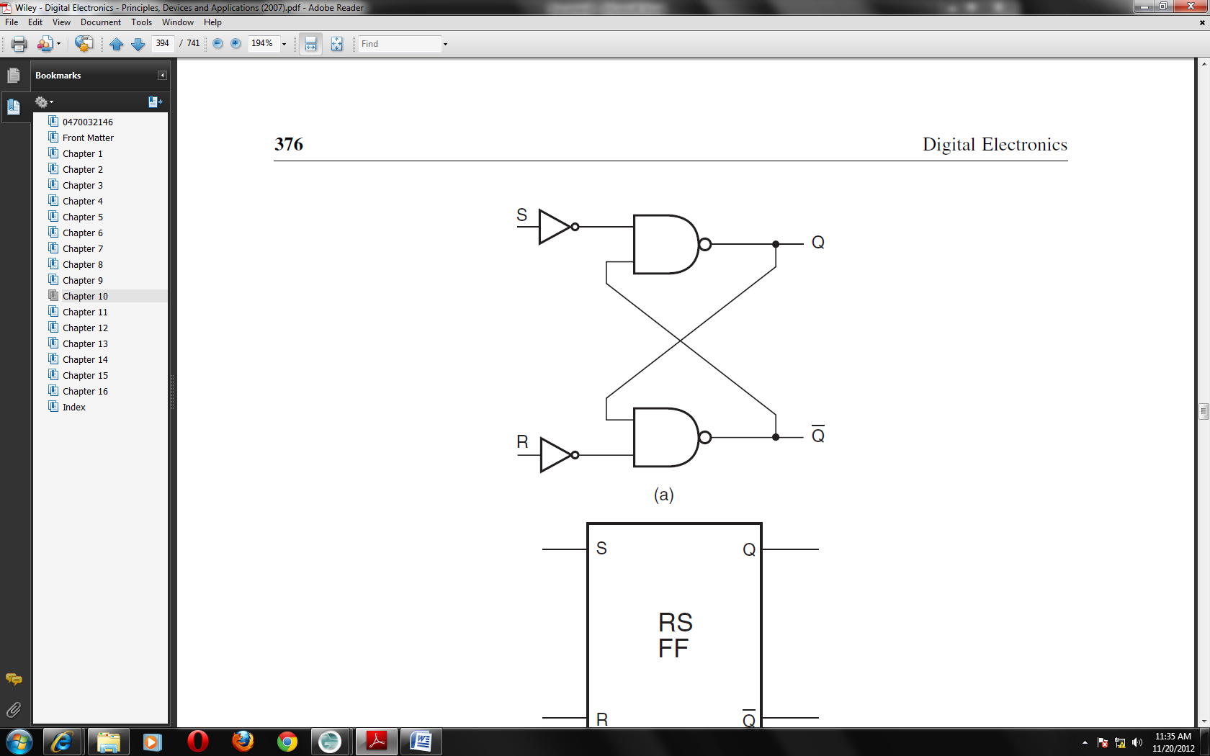

The R-S flip-flops (or latches) above may also be implemented with NOR gates. The NOR gate counterparts are respectively shown in the figure below. So far we have discussed the operation of an R-S flip-flop with the help of its logic diagram and the function table on lines similar to the case of combinational circuits. We do, however, appreciate that a sequential circuit would be better explained if we expressed its output (immediately after it was clocked)in terms of its present output and its inputs.
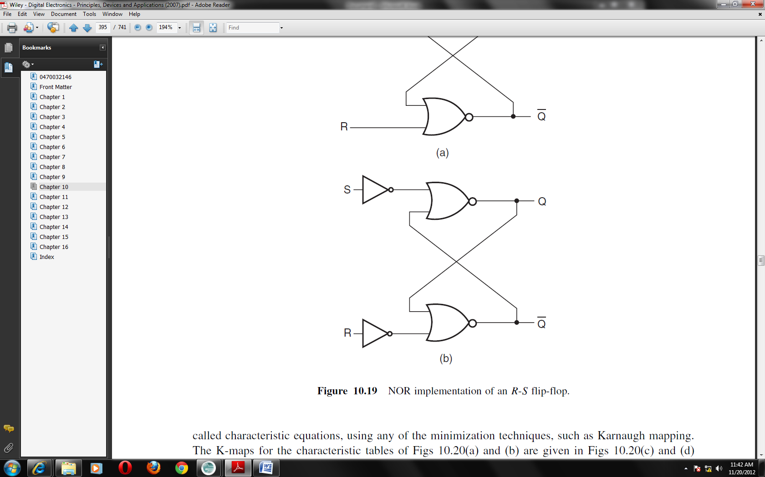
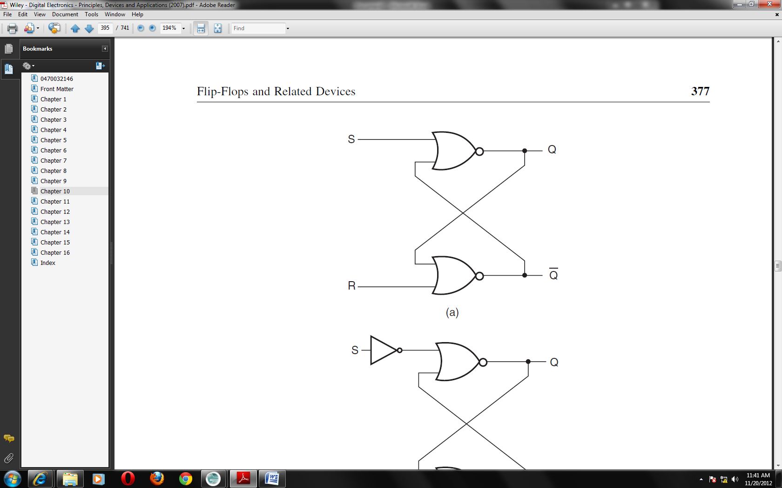

Clocked R-S Flip-Flop
In the case of a clocked R-S flip-flop or for that matter any clocked flip-flop, the outputs changes states as per the inputs only on the occurrence of a clock pulse. The clocked flip-flop could be a level-triggered one or an edge-triggered one. The two types are discussed in the next section. For the time being, let us first see how the flip-flop of the previous section can be transformed into a clocked flip-flop. The figure below shows the logic implementation of a clocked flip-flop that has active HIGH inputs. The function table for the same is shown and is self-explanatory.
The basic flip-flop is the same as that shown earlier. The two NAND gates at the input have been used to couple the R and S inputs to the flip-flop inputs under the control of the clock signal. When the clock signal is HIGH, the two NAND gates are enabled and the S and R inputs are passed on to flip-flop inputs with their status complemented. The outputs can now change states as per the status of R and S at the flip-flop inputs. For instance, when S = 1 and R = 0 it will be passed on as 0 and 1 respectively when the clock is HIGH. When the clock is LOW, the two NAND gates produce a ‘1’ at their outputs, irrespective of the S and R status. This produces logic ‘1’ at both inputs of the flip-flop, with the result that there is no effect on the output states.
The other figure below shows the clocked R-S flip-flop with active LOW R and S inputs. The logic implementation here is a modification of the basic R-S flip-flop. The truth table of this flip-flop, is also given
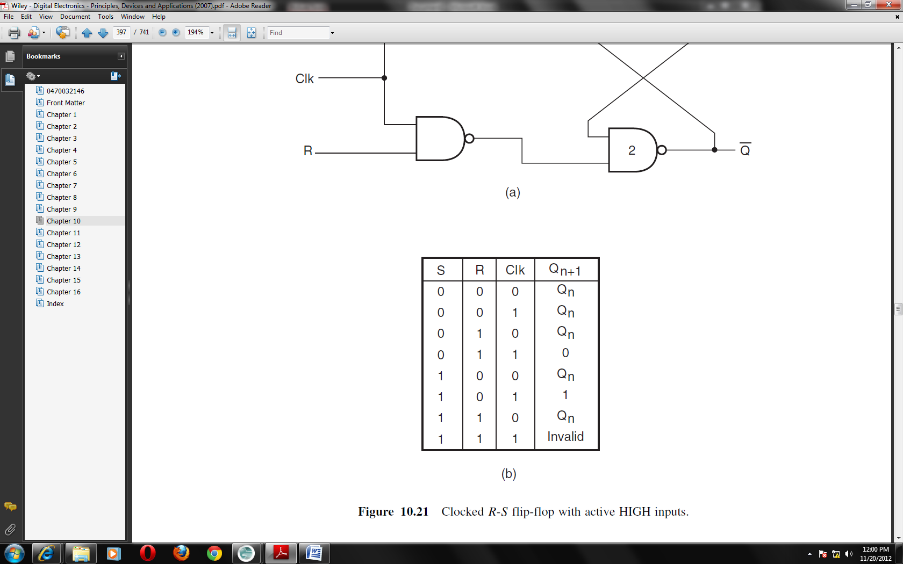
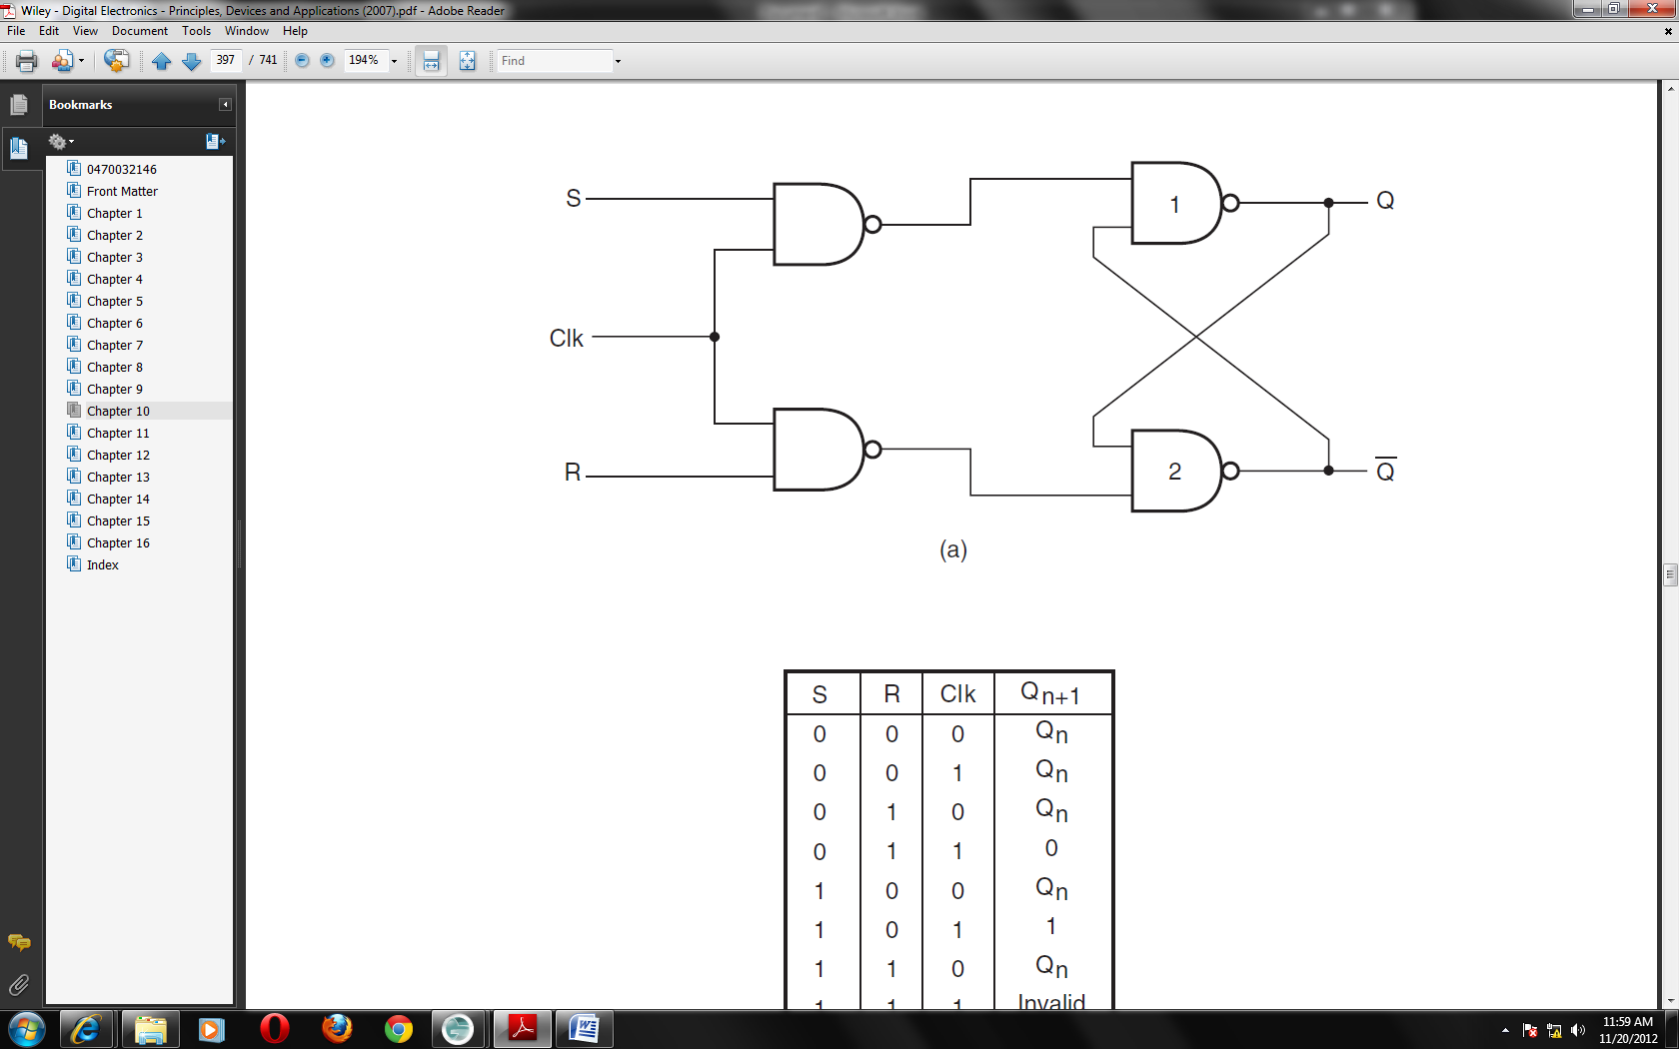

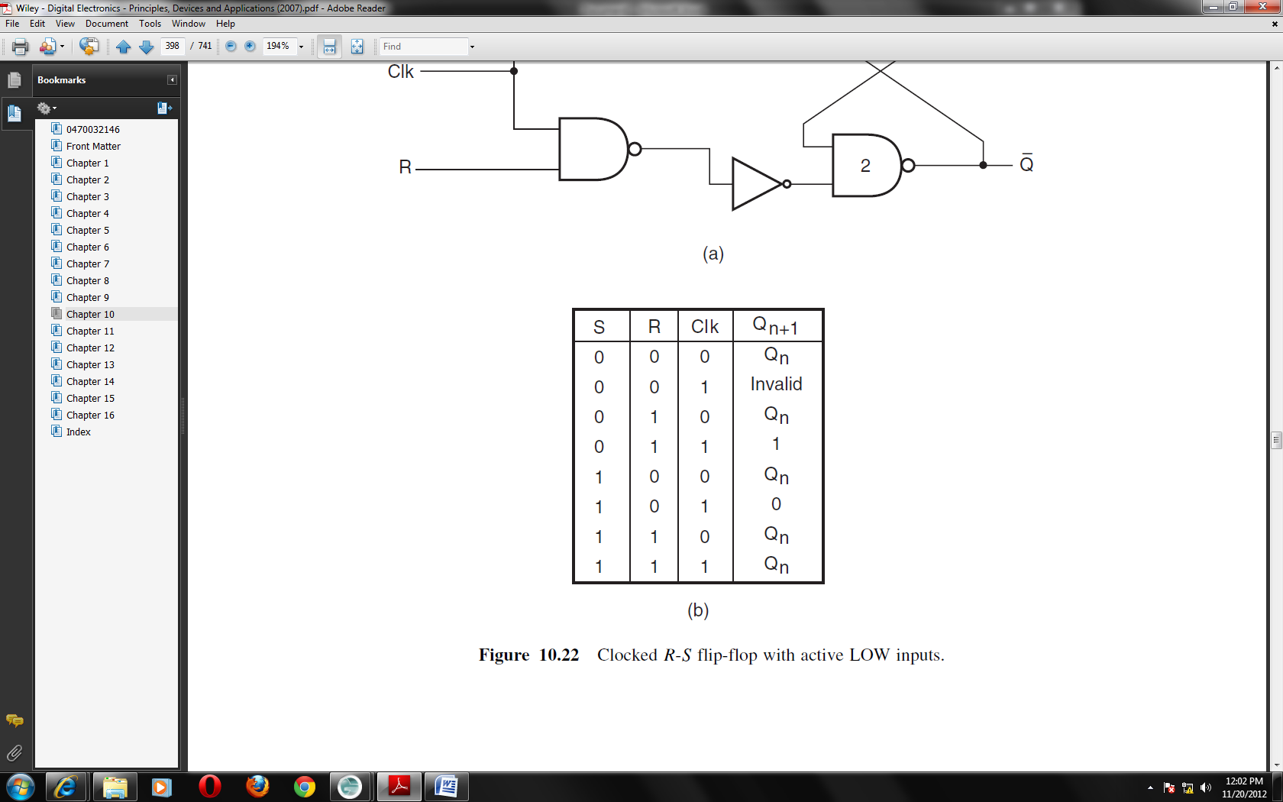
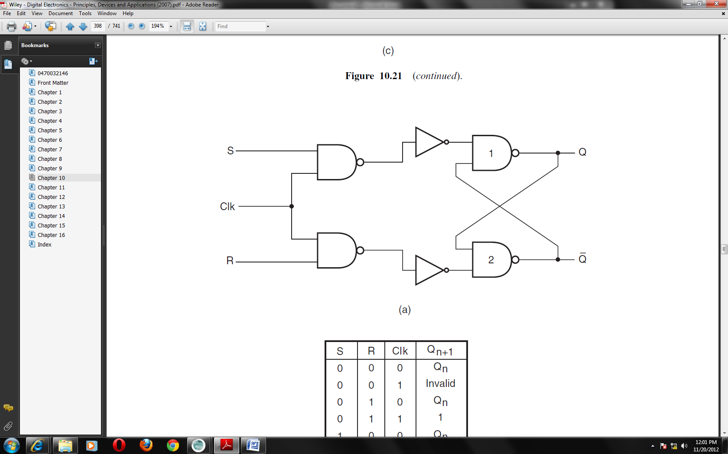
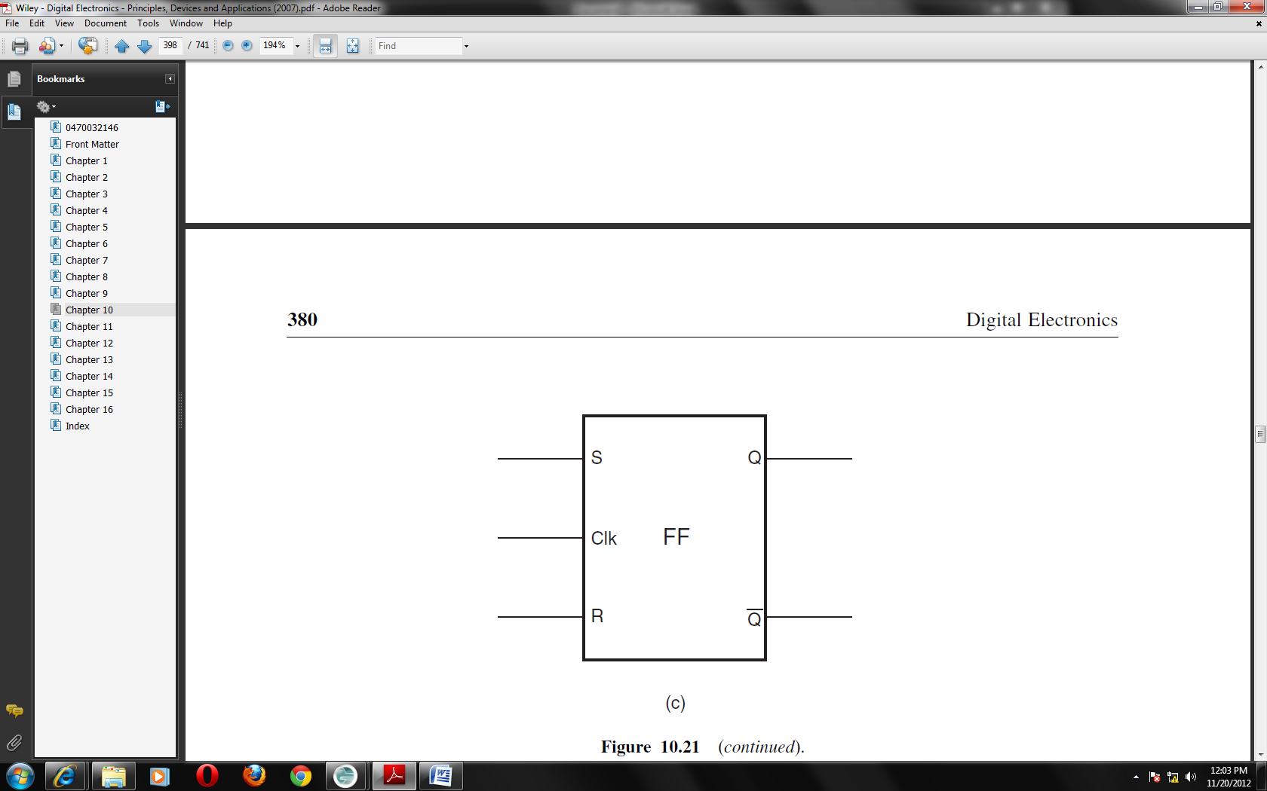
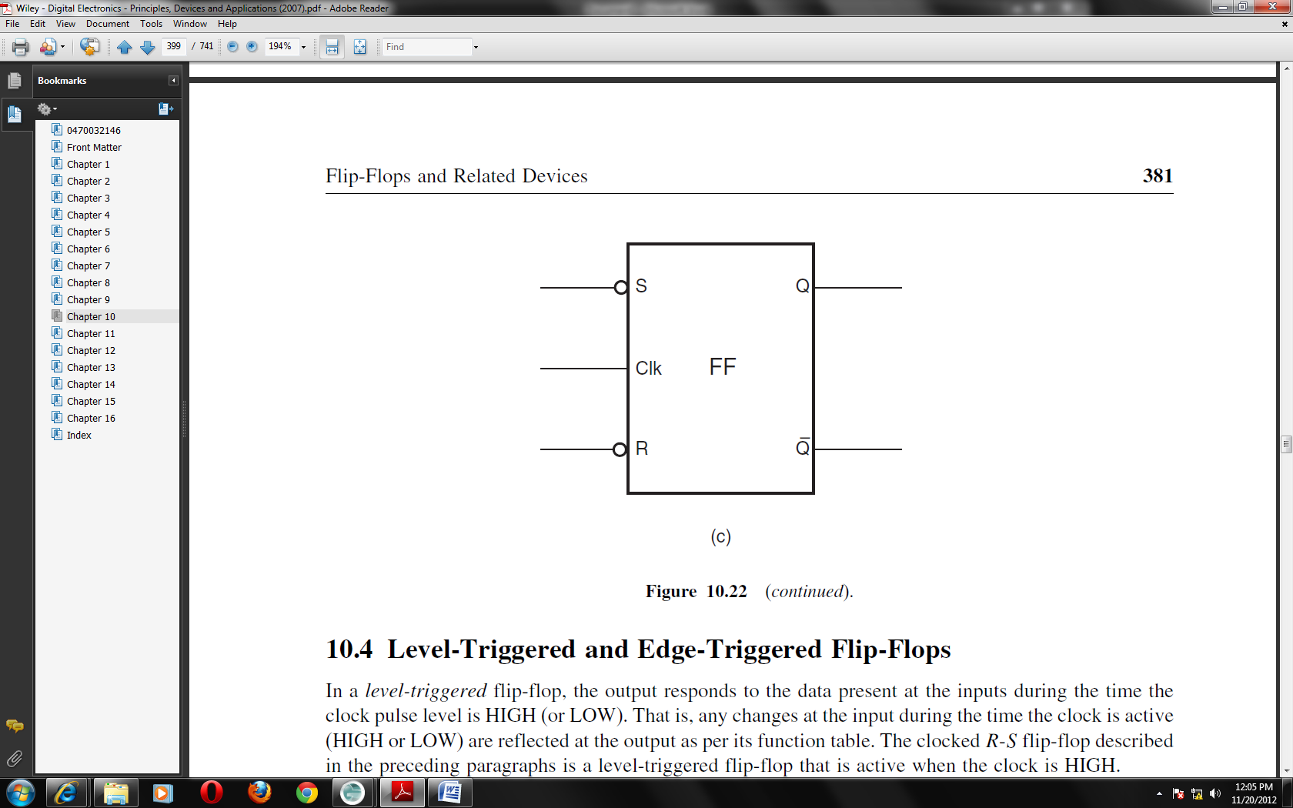

Level-Triggered and Edge-Triggered Flip-Flops
In a level-triggered flip-flop, the output responds to the data present at the inputs during the time the clock pulse level is HIGH (or LOW). That is, any changes at the input during the time the clock is active (HIGH or LOW) are reflected at the output as per its function table. The clocked R-S flip-flop described in the preceding paragraphs is a level-triggered flip-flop that is active when the clock is HIGH.
In an edge-triggered flip-flop, the output responds to the data at the inputs only on LOW-to-HIGH or HIGH-to-LOW transition of the clock signal. The flip-flop in the two cases is referred to as positive edge triggered and negative edge triggered respectively. Any changes in the input during the time the clock pulse is HIGH (or LOW) do not have any effect on the output. In the case of an edge triggered flip-flop, an edge detector circuit transforms the clock input into a very narrow pulse that is a few nanoseconds wide. This narrow pulse coincides with either LOW-to-HIGH or HIGH-to-LOW transition of the clock input, depending upon whether it is a positive edge-triggered flip-flop or a negative edge-triggered flip-flop. This pulse is so narrow that the operation of the flip–flop can be considered to have occurred on the edge itself.
The figure below shows the clocked R-S flip-flop with the edge detector block incorporated in the clock circuit. The width of the narrow pulse generated by this edge detector circuit is equal to the propagation delay of the flip-flop. The circuit symbol for the positive edge-triggered flip-flop and the negative edge-triggered flip-flop is shown.
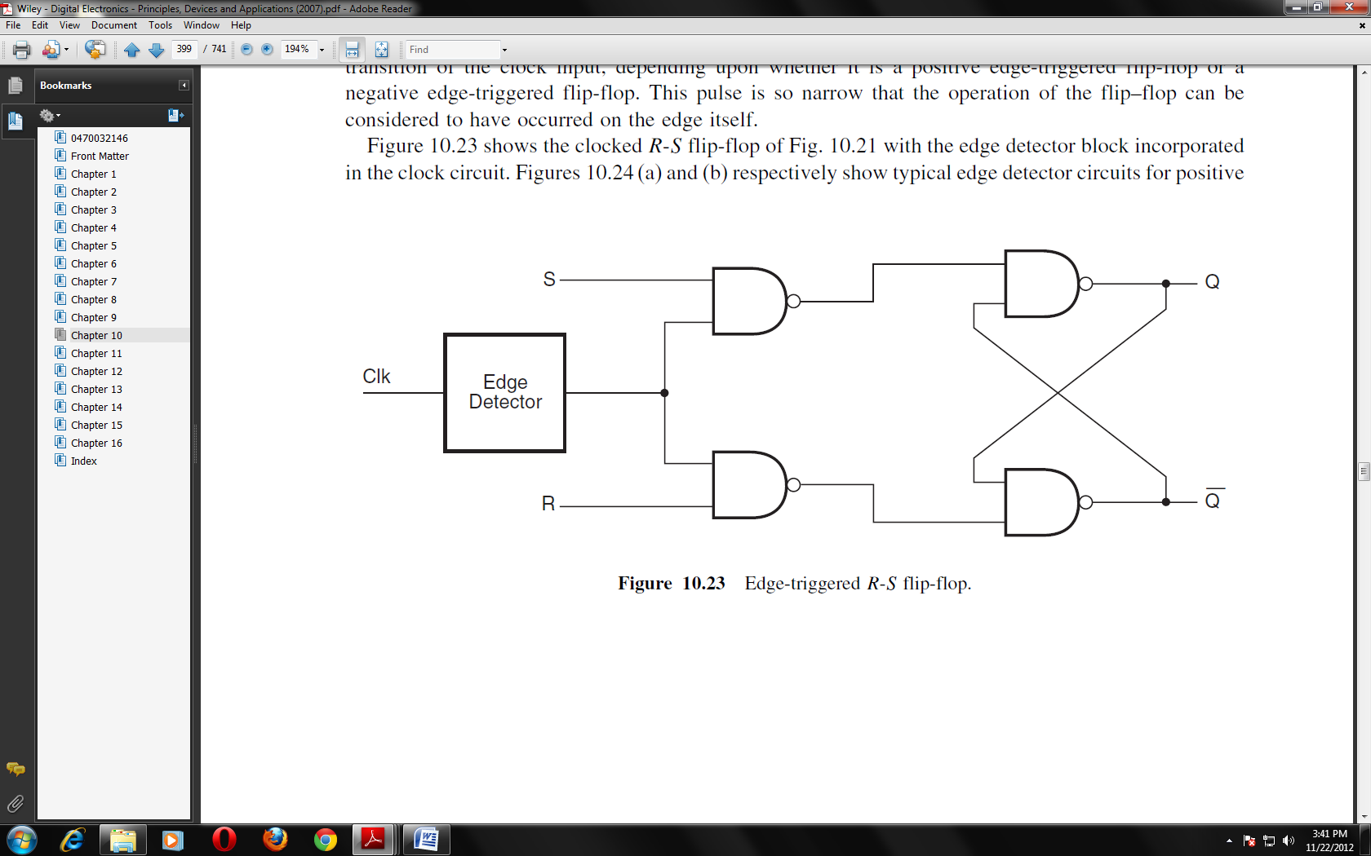

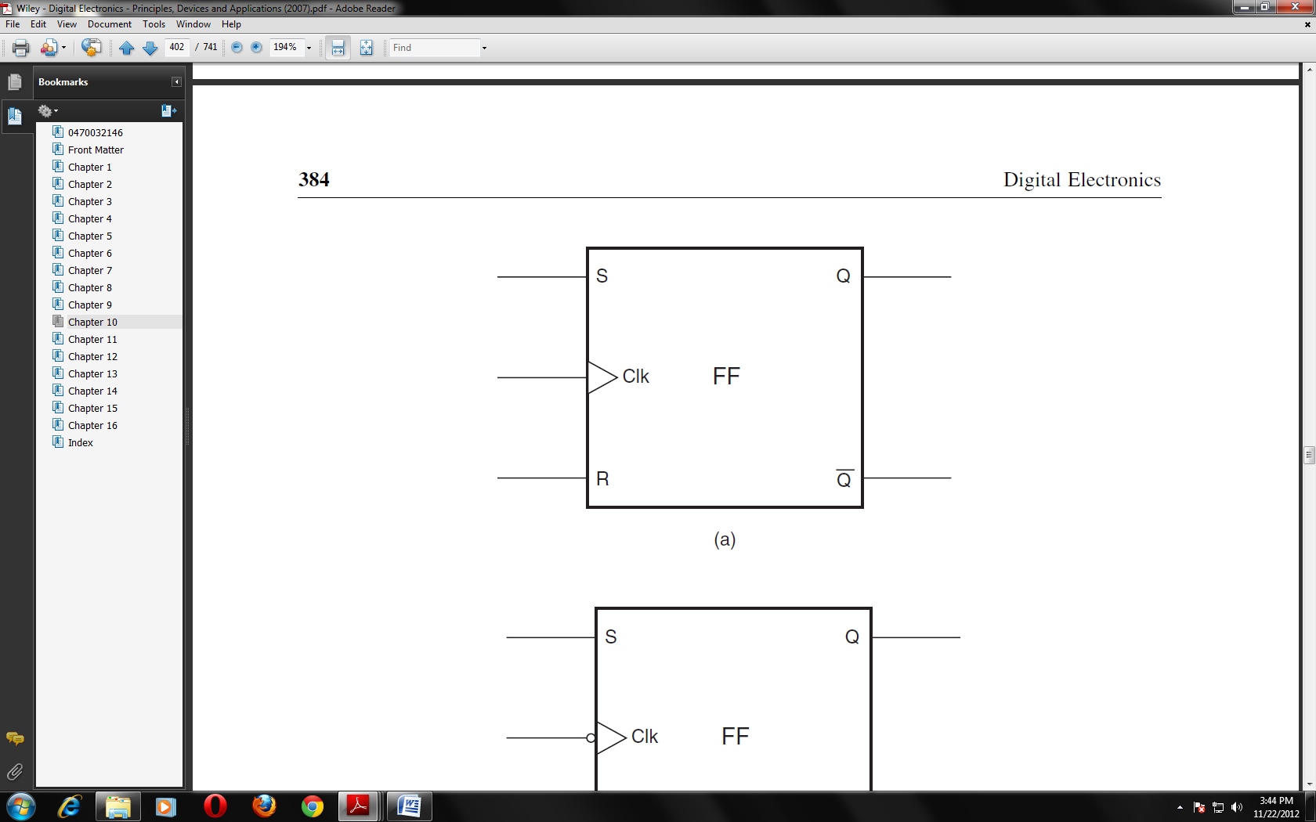
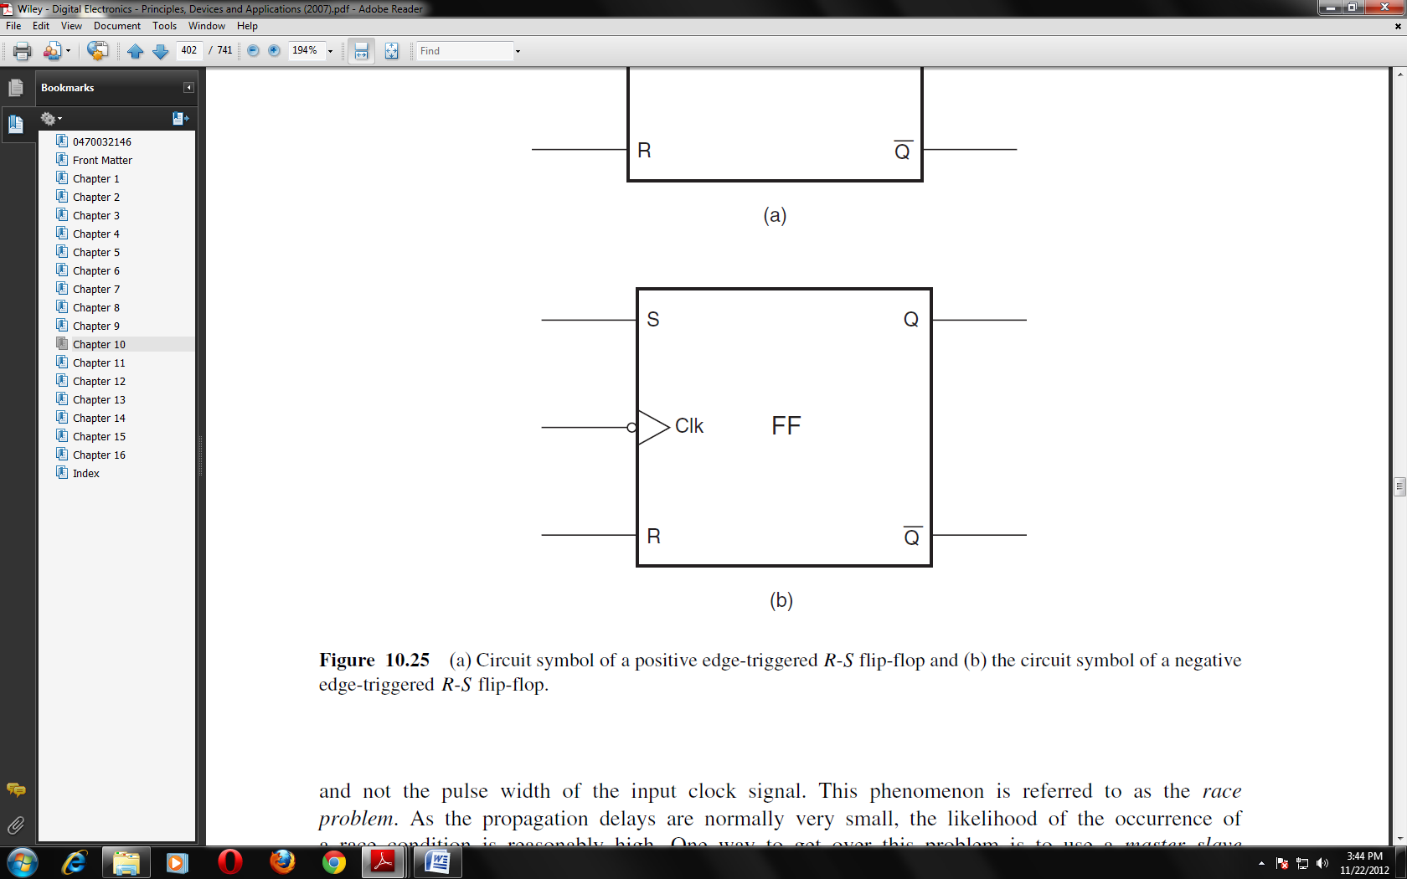

J-K Flip-Flop
A J-K flip-flop behaves in the same fashion as an R-S flip-flop except for one of the entries in the function table. In the case of an R-S flip-flop, the input combination S = R = 1 (in the case of a flip-flop with active HIGH inputs) and the input combination S = R = 0 (in the case of a flip-flop with active LOW inputs) are prohibited. In the case of a J-K flip-flop with active HIGH inputs, the output of the flip-flop toggles, that is, it goes to the other state, for J = K = 1 . The output toggles for J = K = 0 in the case of the flip-flop having active LOW inputs. Thus, a J-K flip-flop overcomes the problem of a forbidden input combination of the R-S flip-flop. The figures below show the circuit symbol of level-triggered J-K flip-flops with active HIGH and active LOW inputs, along with their function tables. The other figure shows the realization of a J-K flip-flop with an R-S flip-flop.
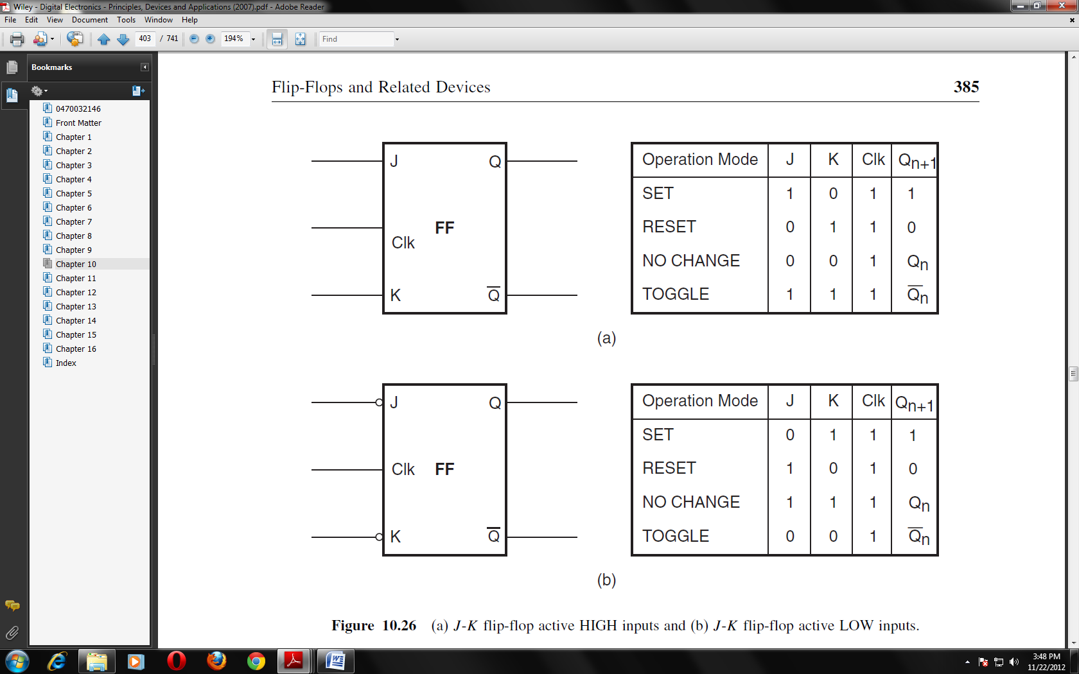
The characteristic tables for a J-K flip-flop with active HIGH J and K inputs and a J-K flip-flop with active LOW J and K inputs are respectively shown below.

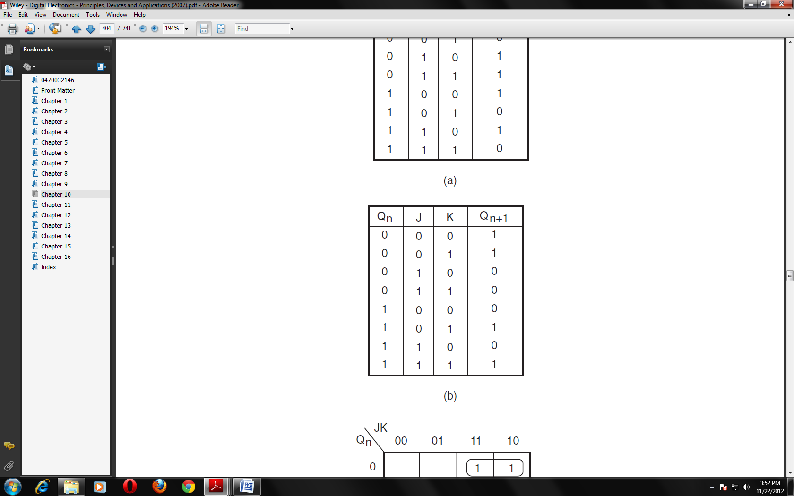
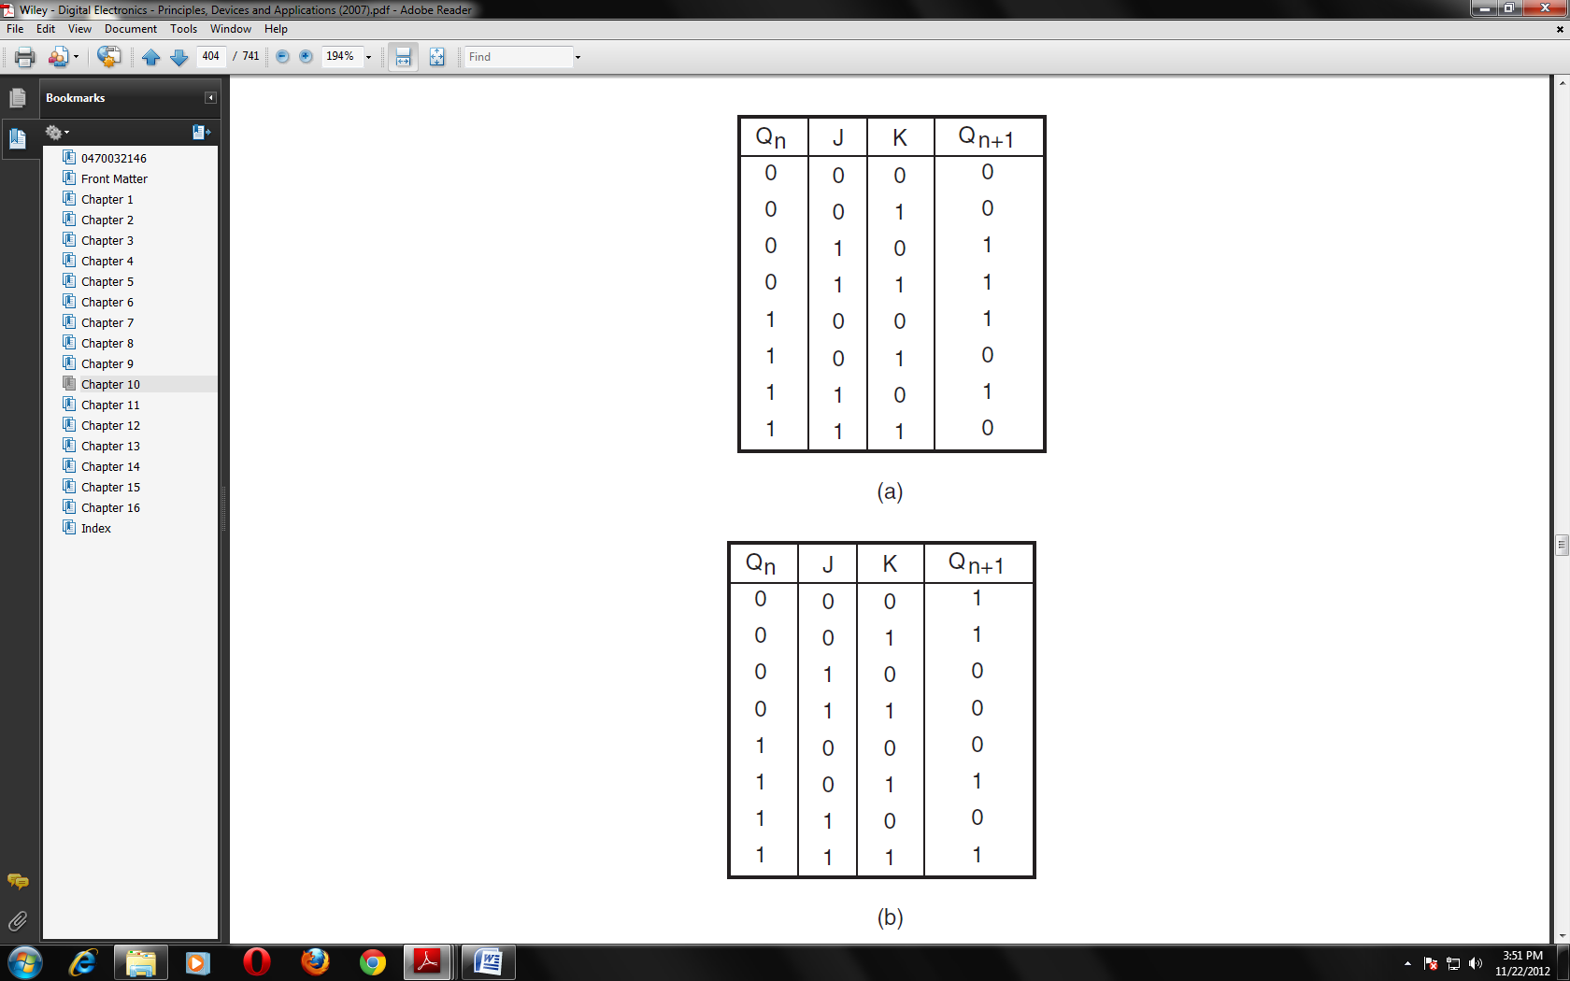


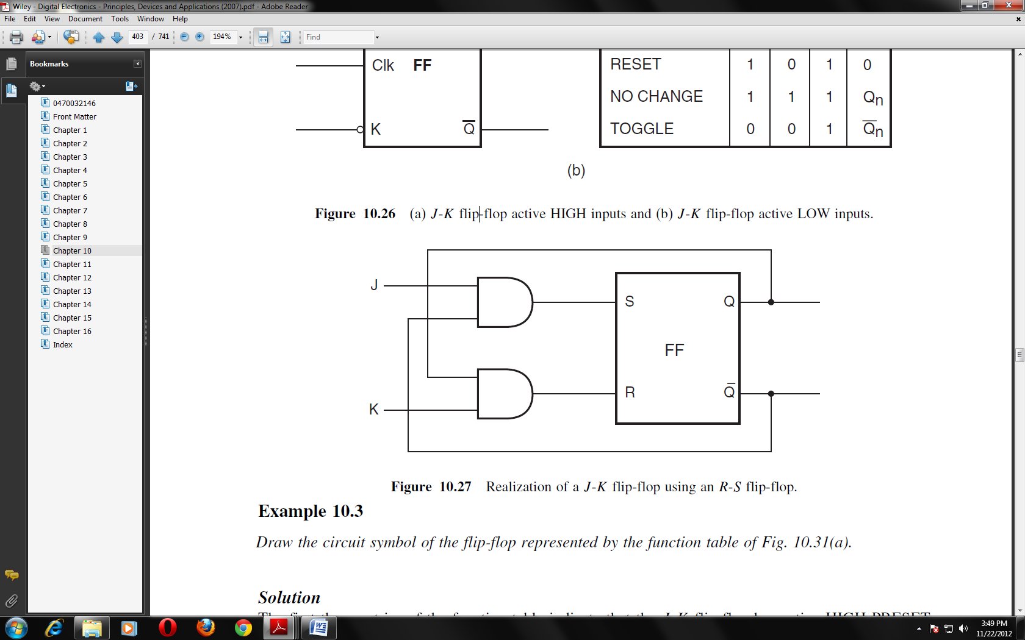

J-K Flip-Flop with PRESET and CLEAR Inputs
It is often necessary to clear a flip-flop to a logic ‘0’ state (Qn = 0) or preset it to a logic ‘1’ state (Qn =1 ). An example of how this is realized is shown below The flip-flop is cleared (that is, Qn = 0) whenever the CLEAR input is ‘0’ and the PRESET input is ‘1’. The flip-flop is preset to the logic ‘1’ state whenever the PRESET input is ‘0’ and the CLEAR input is ‘1’. Here, the CLEAR and PRESET inputs are active when LOW. The circuit symbol of this presettable, clearable, clocked J-K flip-flop is shown.

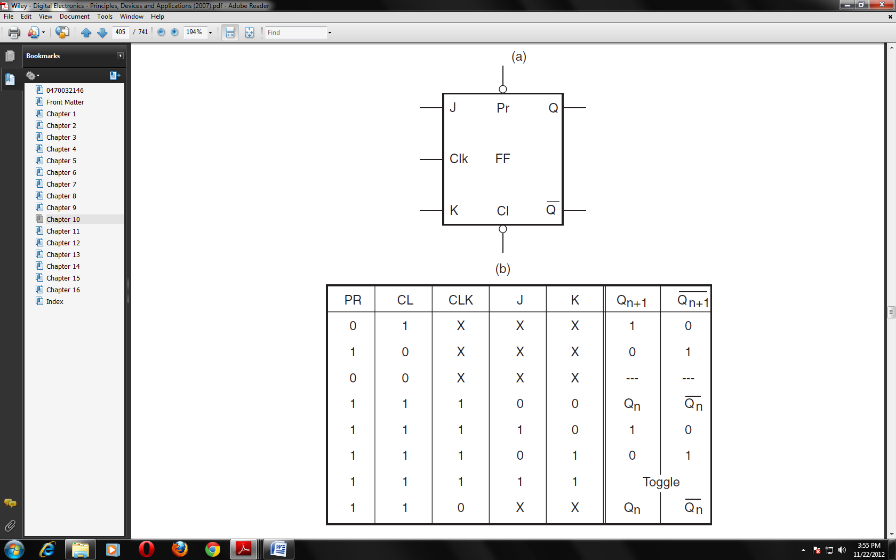
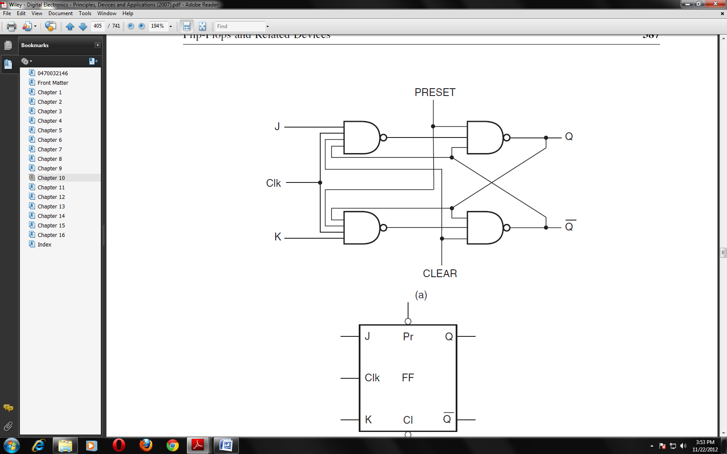

Master–Slave Flip-Flops
Whenever the width of the pulse clocking the flip-flop is greater than the propagation delay of the flip-flop, the change in state at the output is not reliable. In the case of edge-triggered flip-flops, this pulse width would be the trigger pulse width generated by the edge detector portion of the flip-flop and not the pulse width of the input clock signal. This phenomenon is referred to as the race problem. As the propagation delays are normally very small, the likelihood of the occurrence of a race condition is reasonably high. One way to get over this problem is to use a master–slave configuration. The figure below shows a master–slave flip-flop constructed with two J-K flip-flops. The first flip-flop is called the master flip-flop and the second is called the slave. The clock to the slave flip-flop is the complement of the clock to the master flip-flop. When the clock pulse is present, the master flip-flop is enabled while the slave flip-flop is disabled. As a result, the master flip-flop can change state while the slave flip-flop cannot. When the clock goes LOW, the master flip-flop gets disabled while the slave flip-flop is enabled. Therefore, the slave J-K flip-flop changes state as per the logic states at its J and K inputs. The contents of the master flip-flop are therefore transferred to the slave flip-flop, and the master flip-flop, being disabled, can acquire new inputs without affecting the output. As would be clear from the description above, a master– slave flip-flop is a pulse-triggered flip-flop and not an edge-triggered one.
